## Lab 3 Introduction to Oscilloscope and Function Generator

### Objectives

1. Practice using the oscilloscope including its menus, cursors, and math functions.
2. Practice using the function generator, including using the DC offset and the sweep function.

# Equipment

Rigol MSO 1074 Oscilloscope, Rigol DG1022 Arbitrary Waveform Function Generator

Please bring a **USB thumb drive** to save the oscilloscope data.

### Background

The oscilloscope (scope) allows engineers/technicians to view voltage signals in real time. This is particularly useful when we are dealing with time-varying signals, such as an AC voltage signal (for example, a sine wave voltage signal). The display on the scope shows voltage on the vertical axis and time on the horizontal axis. The scope has several channels so that one can view multiple signals simultaneously. There are also many special functions and measurement tools that can simplify the analysis of the signals.

The waveform function generator generates periodic AC voltage signals, such as sine waves, square waves, and ramps. It can also generate signals that have a DC component to them – this is called a DC offset. Our function generator has two channels. We will explore the function generator first.

# Part 1: Function Generator – exercise only, no data to record

Here is the front of the function generator that you will use in this lab.



Become familiar with the function generator operation by performing the following exercise.

a. The function generator uses generic BNC-to-alligator/minigrabber connectors. In contrast, the scope may use either the generic BNC-to-alligator/minigrabber connectors, or the scope’s own special attenuation probes (for attenuation purpose only). **Never connect the special oscilloscope probes to the generator!**

b. Connect two BNC-to-alligator/minigrabber connectors to channel-1 and channel-2.

c. Set Channel-1 to Sine, 1 kHz, 4 Vpp (peak-to-peak voltage), 0 Vdc (DC voltage) offset. To produce the periodic sine wave signal output, press the **output** button next to Channel-1. Now set Channel-2 to Sine, 5V p-p, 2 kHz, 0Vdc offset. **Do not press the output buttons yet.**

Note that no signal can be seen at this time, because the signals generated by the function generator must be sent to the scope in order to be viewed.

In the next part of the lab, we will familiarize ourselves with the scope, particularly in the following main areas:

1. calibration: use the scope’s internal signal generator to calibrate the scope’s attenuation probes
2. auto waveform display: measure and display AC waveforms
3. probe attenuation: match the probe type/setting with the scope’s probe setting
4. horizontal and vertical controls: stretch and squeeze the waveform displays
5. coupling: understand the difference between DC coupling and AC coupling
6. inversion function: invert the actual waveform
7. measurement: displays detailed measurement of various AC signal parameters
8. triggering: use triggering to stabilize a waveform display
9. math function: applying a math function to process two or more signals

**Part 2: Oscilloscope – become familiar with its operations; save waveforms as instructed**



**Part 2-1 Calibration of the special scope probe using the scope’s own signal generator**

1. The scope has its special **attenuation probe** that must be calibrated frequently. If you use the generic BNC-alligator/minigrabber probe, the generic probe does not need calibration. Connect two scope attenuation probes to Ch-1 and Ch-2 on the scope. Make sure the slider switch on the probe tip is on the 10X setting. If your probe does not have a slider switch between 1X and 10X, then find out if your probe is 1:1 or 10:1 probe. Follow the same procedure below. Whatever probe you use, after calibration you need to make sure that your scope’s probe setting must agree with your probe’s type/setting (1:1 or 10:1).
2. Press **Storage 🡪 Default** to restore the scope to its factory default configuration.
3. Calibrate scope probe connected at Ch-1: clip the small black alligator of the probe to the bottom (ground) flange at the calibration port. Clip the probe tip to the top (signal output) flange at the calibration port (where the scope’s internal signal generator sends out a square wave).
4. Press the “**Auto**” button. The calibration port should produce a pre-determined square wave. If you see nothing on the scope screen, press “**Auto**” again, and wait for the square wave to appear. You should only see Ch-1 output (yellow signal) on the screen. **Attach a thumb drive to the scope, and save the image** on your thumb drive with “Quick Print to USB” key.

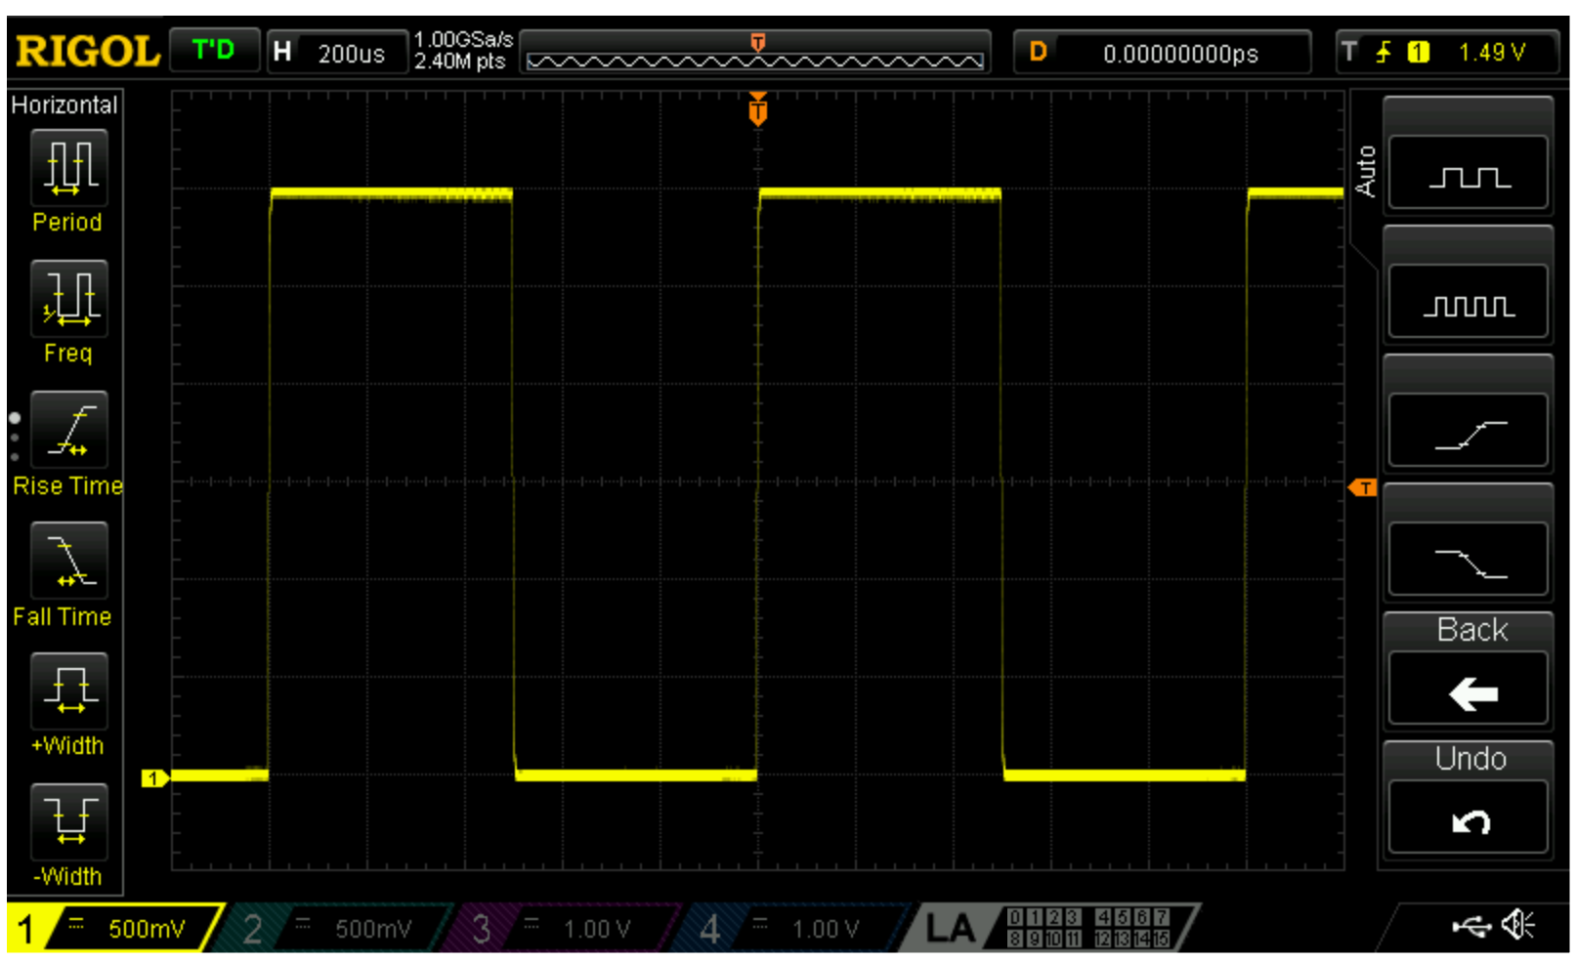

1. If the square wave is already clean (meaning: the square wave does not have the rise or decay in the square wave’s high and low values), then you don’t need to do anything. If not, then use the small screw driver provided with the probes to adjust the probe until the square wave on Ch-1 is clean. The following picture shows three square waves, the middle one is what you want to achieve.

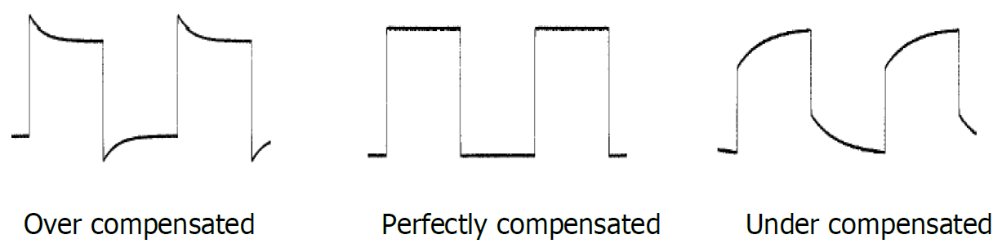

1. Do this step for the other probe at Ch-2. (You may need to disconnect probe 1 from Ch-1 when you calibrate Ch-2 probe, and then reconnect the Ch-1 probe when you are done with calibration). Ch-2 calibration wave may look like this:

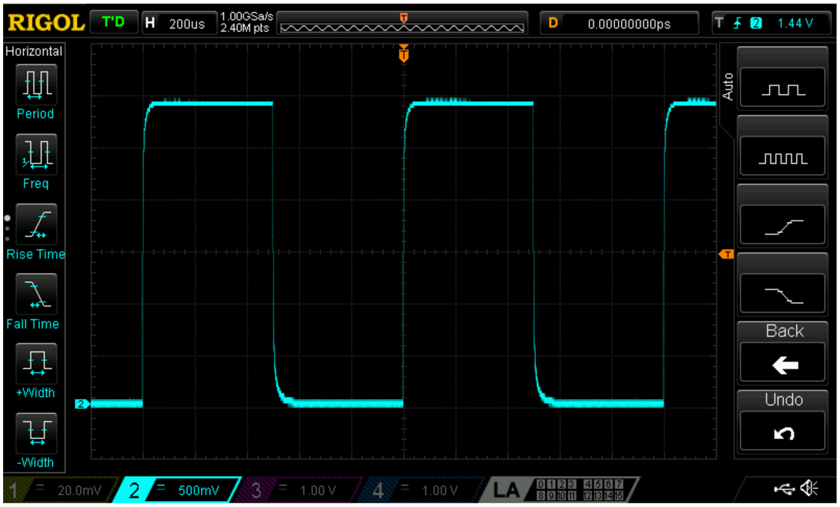

**Part 2-2 Using scope to auto display AC waveforms – primary use of the scope**

1. Now connect the scope’s Ch-1 to the function generator’s Ch-1 (You may want to temporarily disconnect Ch-2 probe just for this measurement). You can use a BNC cable to make the connection. Alternatively, you can attach a BNC-alligator/minigrabber cable to Ch-1 of the function generator, attach another BNC-alligator/minigrabber cable (or the scope’s special attenuation probe) to Ch-1 of the scope, and connect the two cables red-to-red and black-to-black. Make sure the generator’s Ch-1 **output** is on, so that the Ch-1 sine wave signal comes out of the generator, and into the scope.
2. Press **Auto** on the scope. You should see the Ch-1 signal from the generator displayed on the scope. **Save the image** on your thumb drive with “Quick Print to USB”. You should get an image like this:

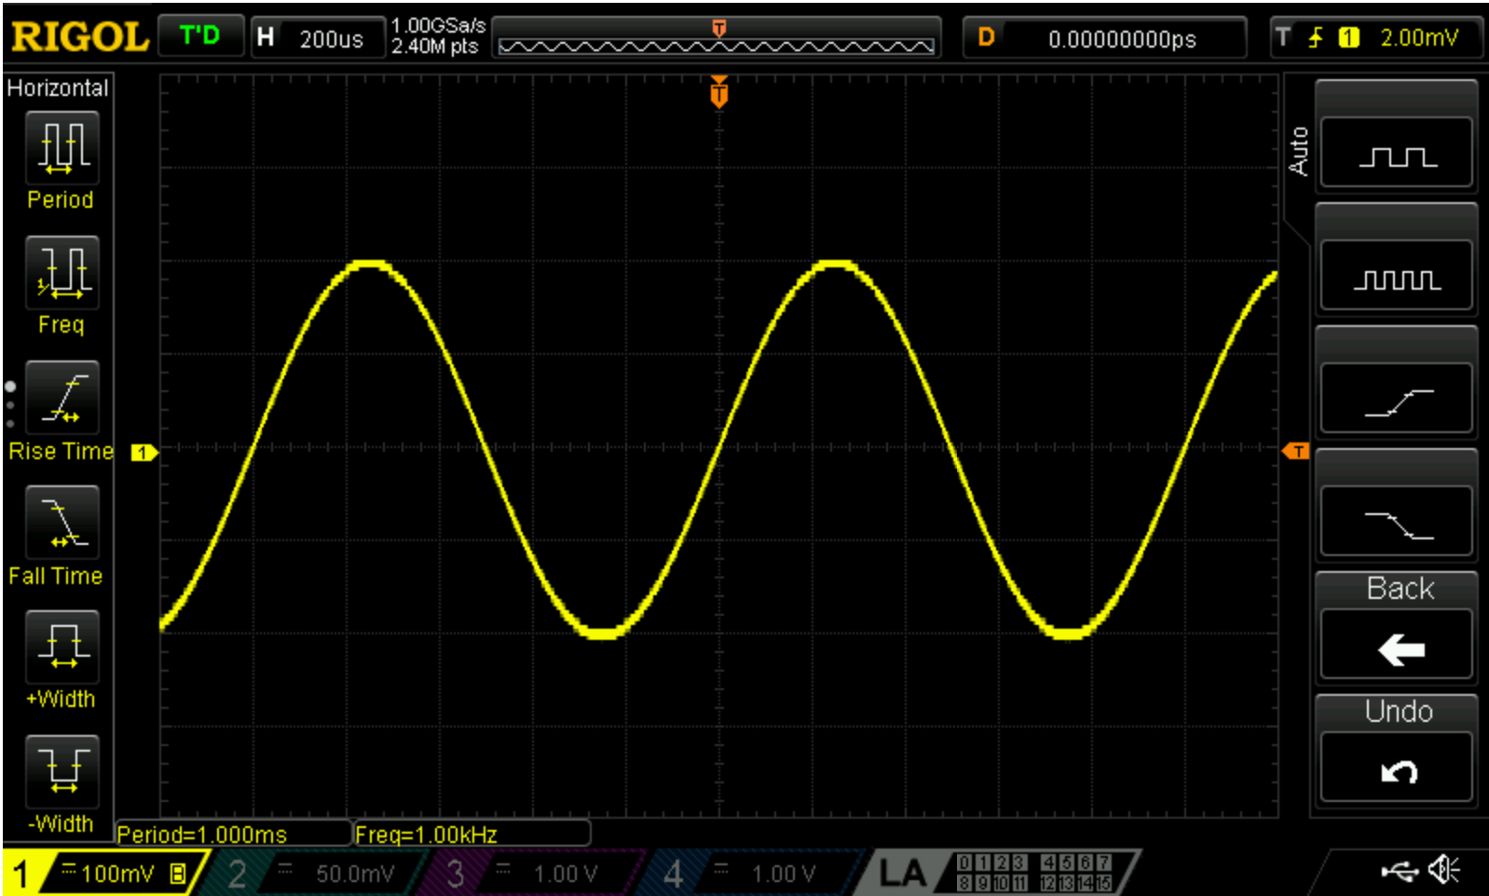

Tip: When you are not measuring the Ch-1 output from the generator, turn off Ch-1 of the generator, and push the “Run/Stop” button on the scope so that it turns red. This will avoid running the generator and the scope unnecessarily. When you are ready to measure again, turn the generator and the scope back on.

Looking at the image above, check the Voltage peak-to-peak (written as Vpp), and see if it is indeed 4 Vpp. Also, look at the Freq reading on the scope and see if it is 1kHz. Note that a period of 1msec means a frequency of 1kHz. Check the period using the horizontal scale.

**Part 2-3: checking and matching probe attenuation**

1. Notice that on the scope’s special attenuation probe there is a slider switch that reads 1X and 10X (if your probe indeed has such a slider). **If your probe does not have a slider, then skip the part where you slide between the two settings of your probe. You just need to make sure that your scope’s probe setting agrees with your probe type.** Move the switch back and forth slowly and watch the response on the scope. What do you see? Does the signal go off the screen? Think about why this happens.
2. Move the slider switch to 1X. To compensate for the1X attenuation (decrease in voltage), set the scope’s Probe setting to 1X by pressing “Ch1” button on the scope and selecting 1X in the Probe menu. **Tricky: the scope’s default factory setting of Probe attenuation is 10X.**

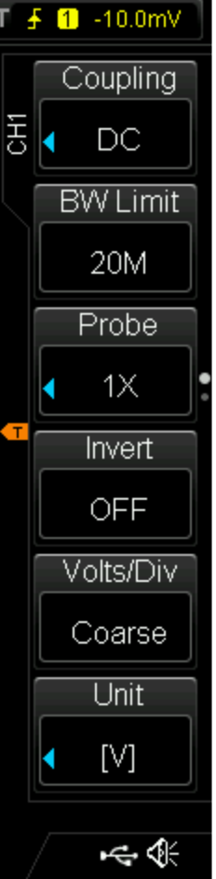

You may need to use the menu knob to scroll to 1X. Then push the menu knob to select 1X. Now press “Auto” on your scope to see the wave form. You should see something like this:

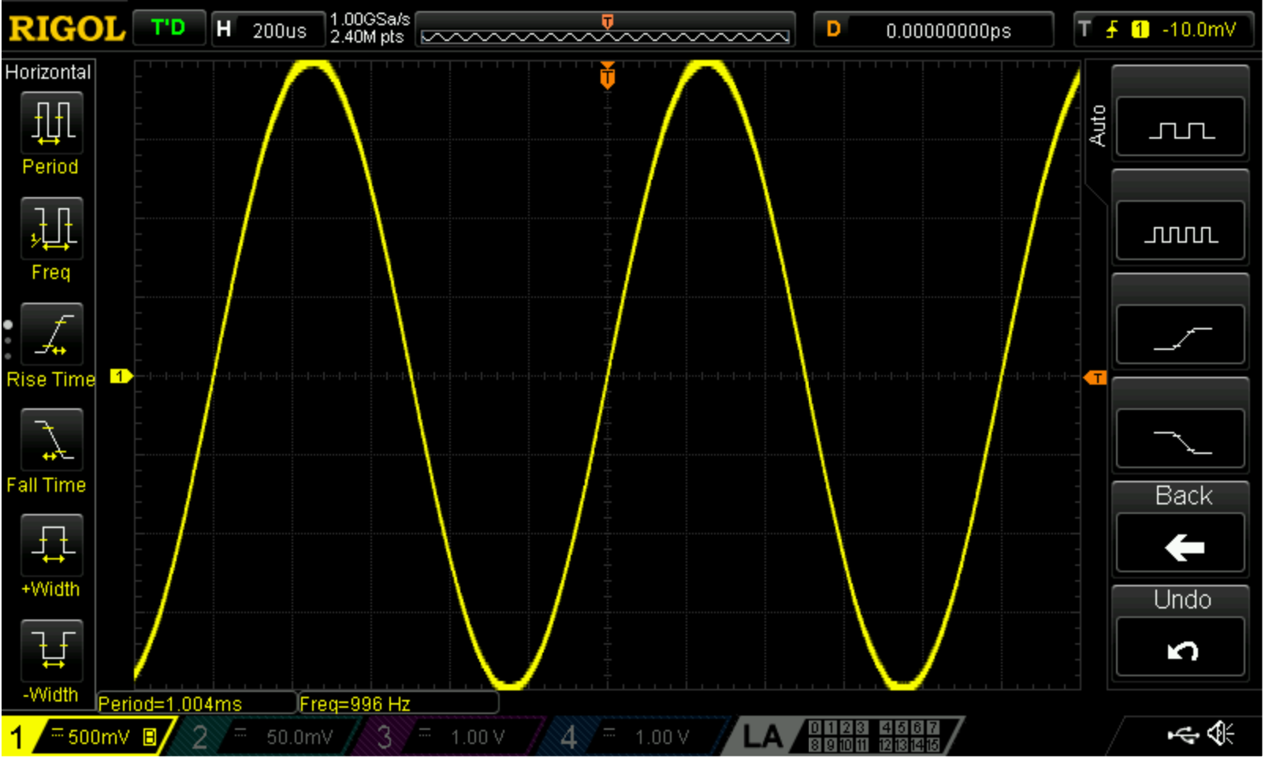

If you now toggle the slider on the attenuation probe to 10X, you will see something like this (since your probe is at 10X, the scope signal will shrink 10 times in response):

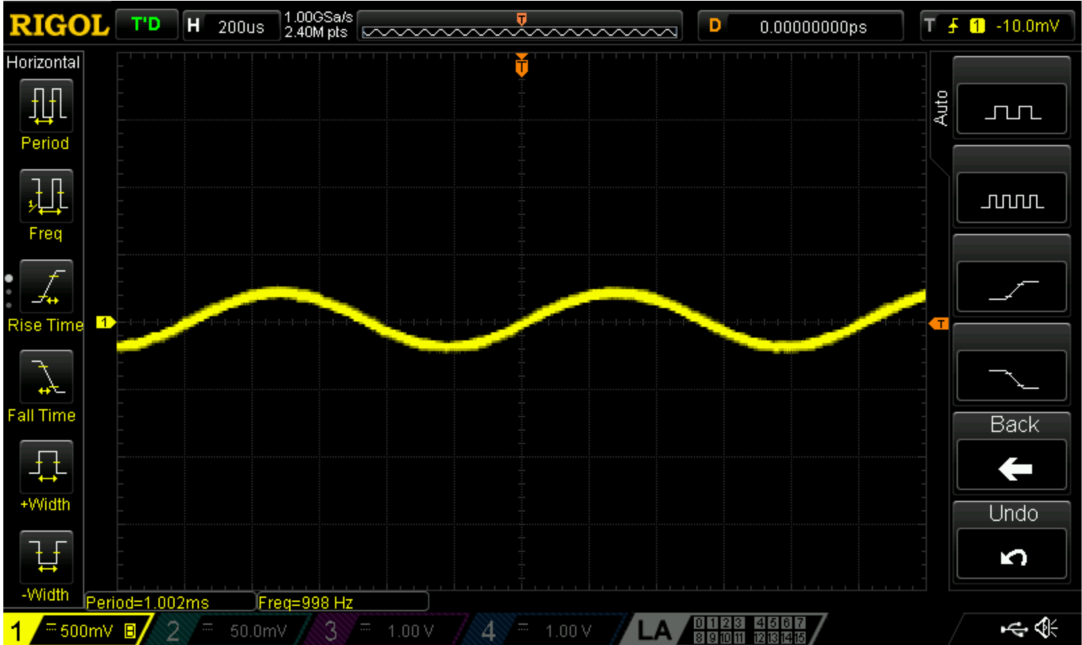

1. In order to ensure that the scope is accurately displaying the correct amplitude of the signal, **the Probe setting on the scope screen should always match the position of the slider switch on the attenuation probe.** If you use the generic BNC-alligator/minigrabber probe, the attenuation is always 1X, so you must set your scope’s Probe setting to 1X.

**Part 2-4: horizontal and vertical controls to stretch and squeeze waveform displays**

1. Next, experiment with the vertical channel controls, i.e., turn the vertical **scale** knob and see what happens to the wave form. Look at the voltage number at the lower left corner of the screen and see what happens. Now turn the vertical **position** knob, and see what happens to the wave form. Look at the POS number at the lower left corner of the screen, and see how it changes. To bring back the default format, you can always push the **Auto** button.
2. Now, experiment with the horizontal channel controls (both the **scale** knob and the **position** knob), and see what happens. Get comfortable with using the horizontal and the vertical channel control knobs.

**Part 2-5: AC and DC coupling of the scope**

1. Next, experiment with the DC/AC coupling of the scope. Use the vertical scale knob to shrink the sine wave. Then push “Channel-1” button to bring up the Coupling setting. Set the Coupling to DC. You should see something like this:

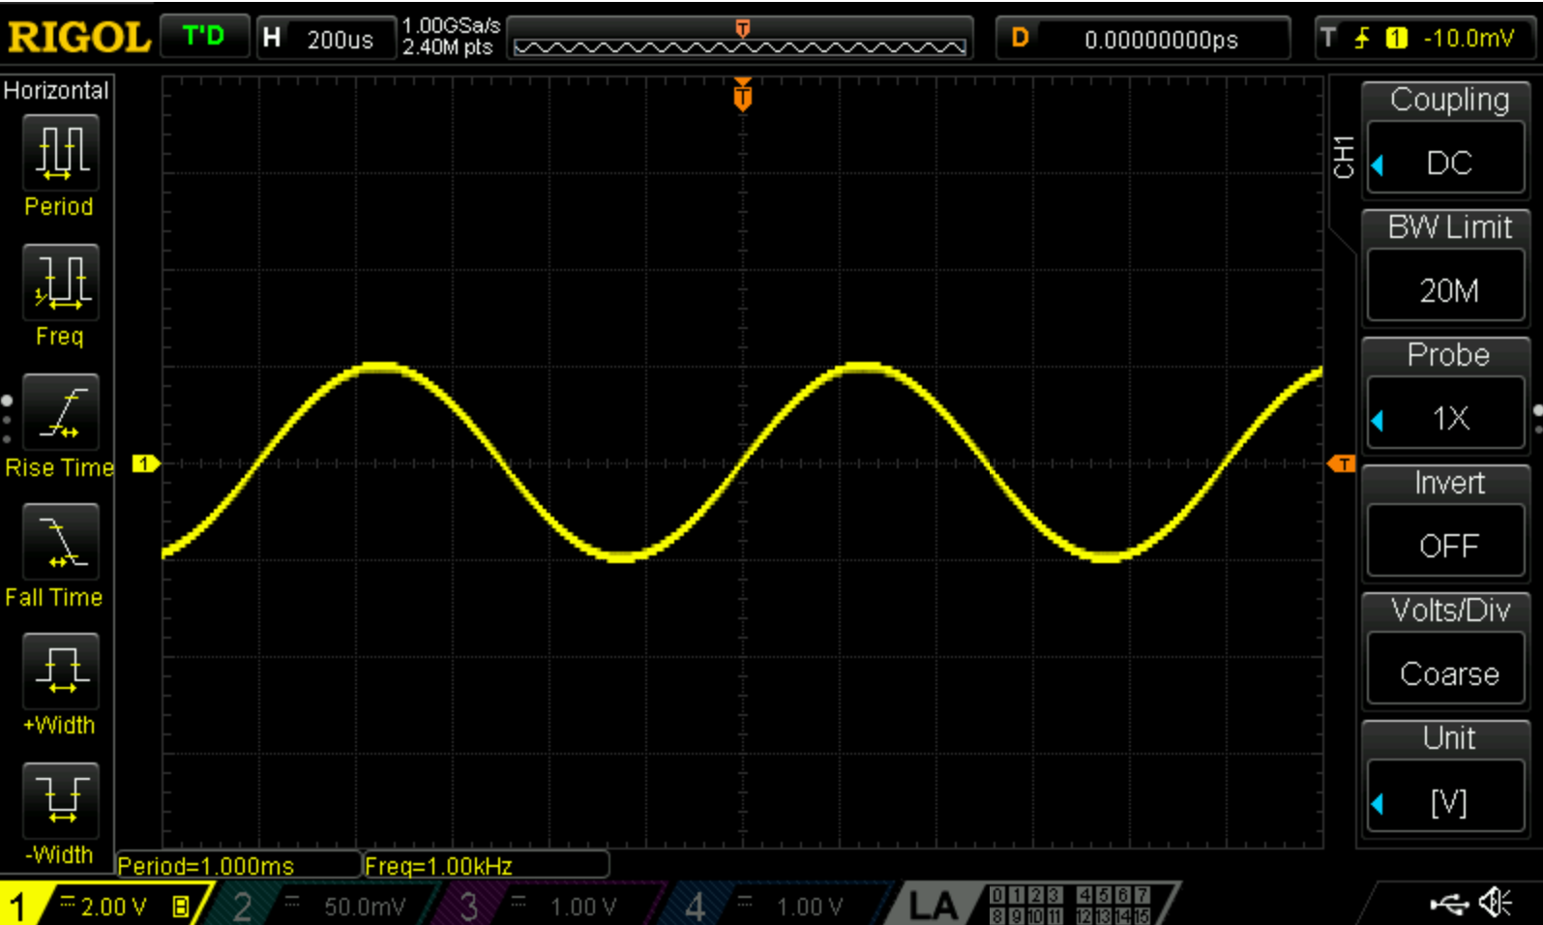

1. Make sure your function generator’s Ch-1 output is still Sine, 1 kHz, 4 Vpp, 0Vdc offset. Now push the Offset button on your generator, and use the dial to change the DC offset to 1Vdc. How does the waveform change on the scope? Change the generator’s offset up and down, and see what happens to the waveform on the scope. For example, here is what a -2Vdc offset might look like on your scope:

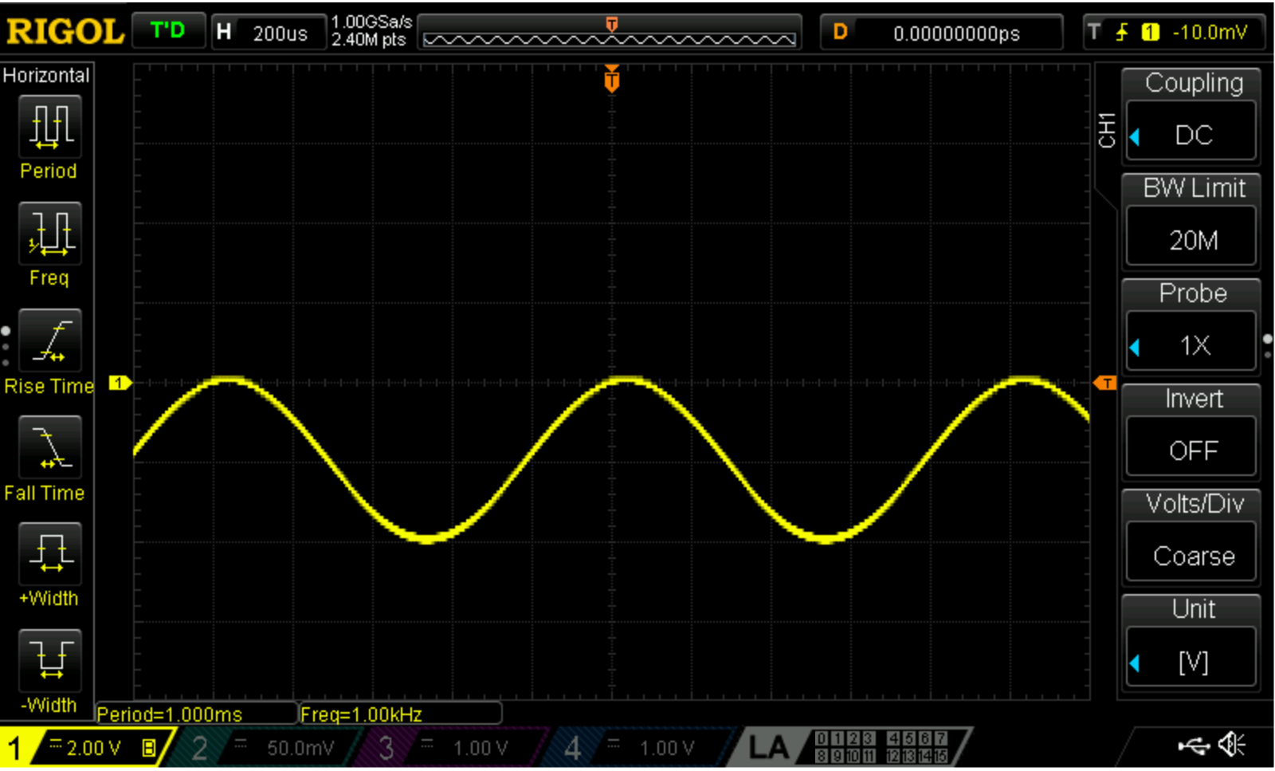

See how the waveform shifts up and down as you change the DC offset, and think about why that happens. **Save two images of your signal (with and without DC offset)** under DC coupling**.**

1. Now set the Coupling of your scope to AC, and repeat the same procedure of changing the offset of the signal coming out of the function generator. Does the waveform shift up and down? What is the difference between the DC coupling and the AC coupling on your scope? **Save an image of the same signal under AC coupling.**

**Part 2-6: inversion of waveform**

1. Adjust the vertical scale knob to 1V per division, and the horizontal scale knob to show 2-3 periods of waves in your scope display. Set the Invert option on the scope screen from “OFF” to “ON”. You should see an inversion of the waveform, like this:

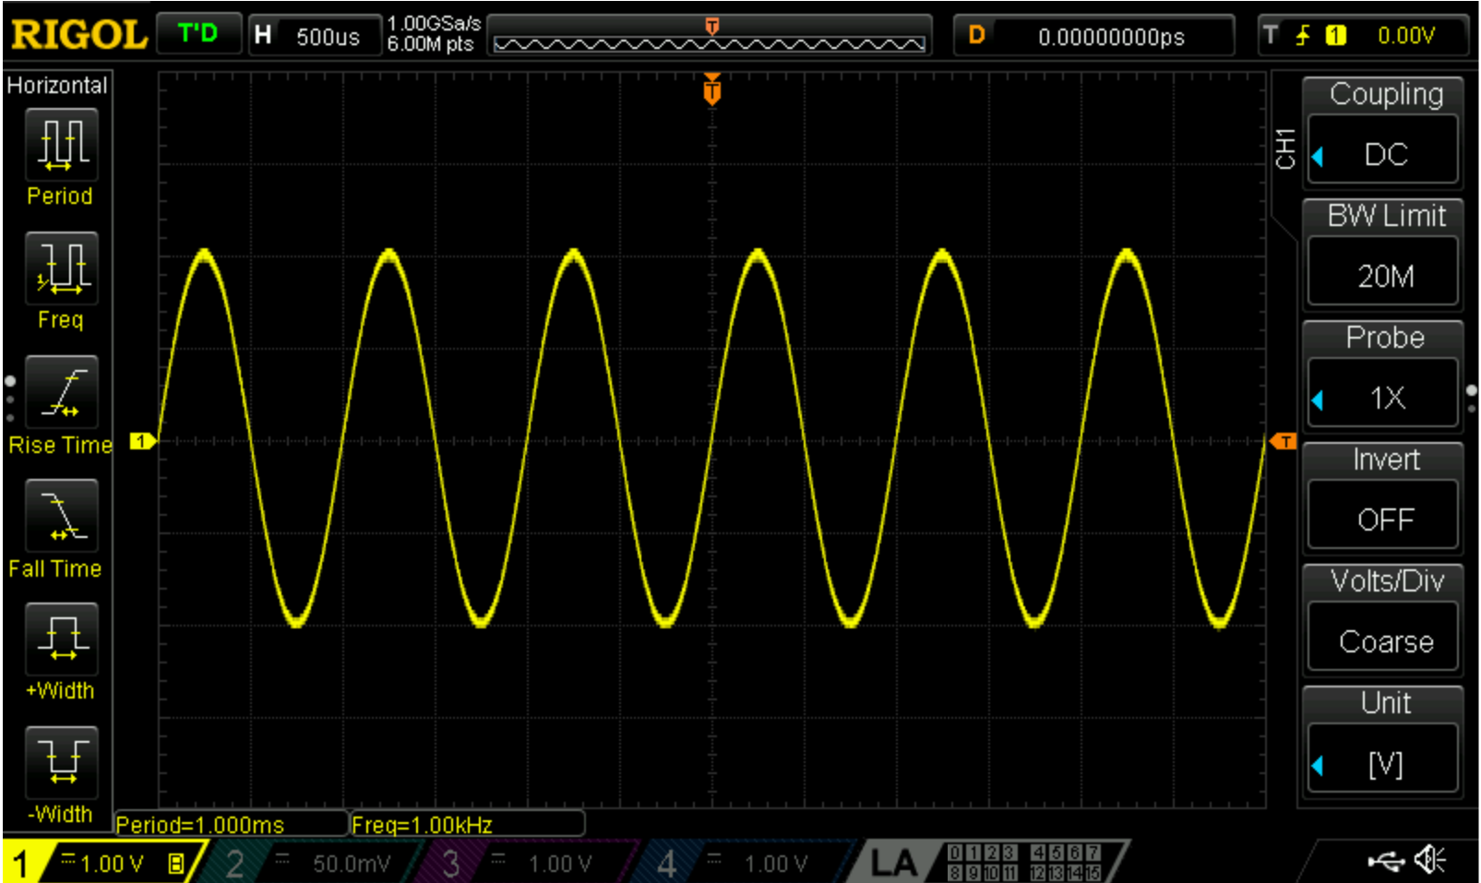

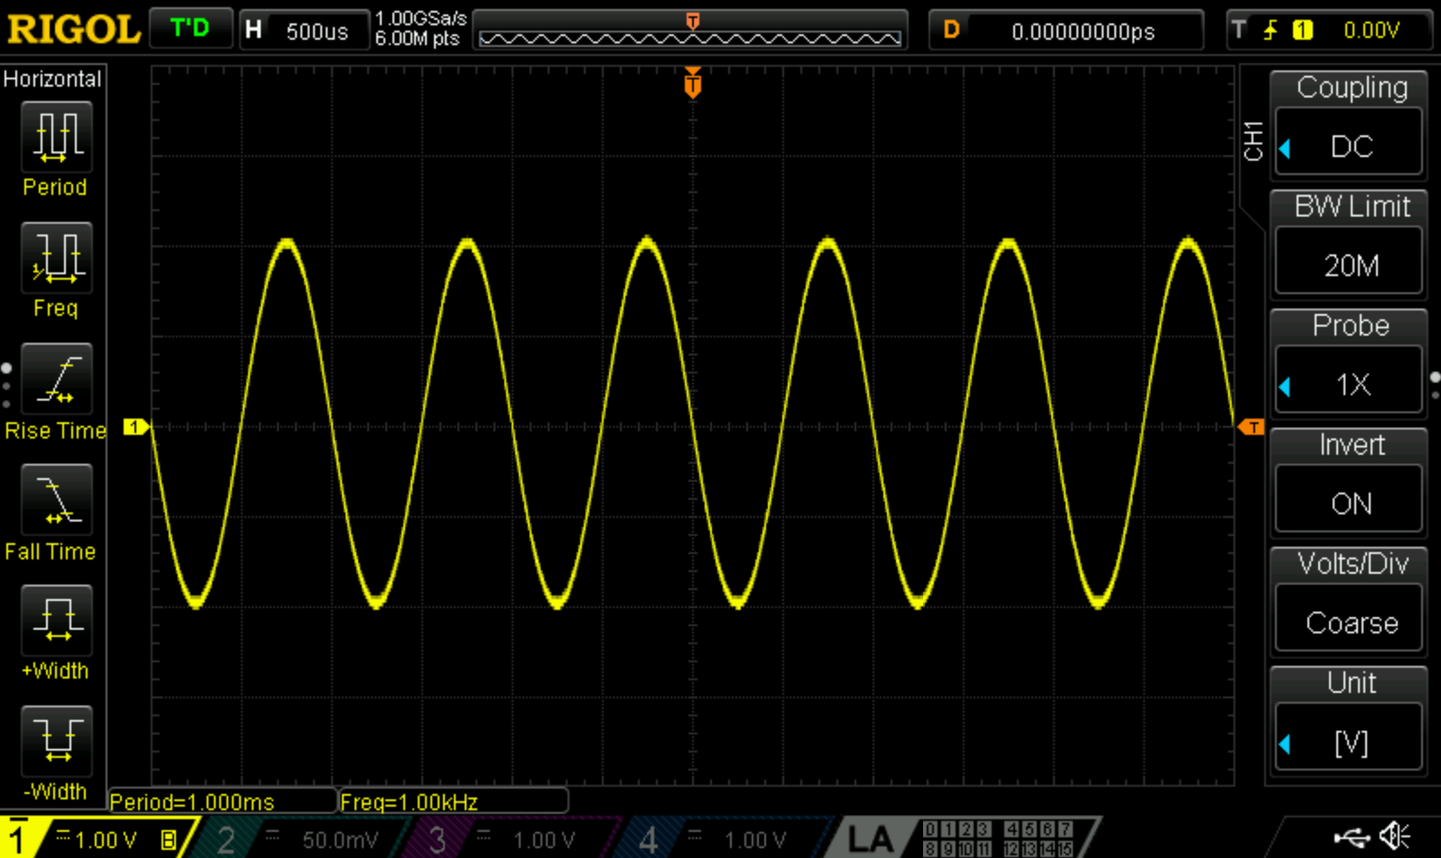

Think about why you may need the scope to invert a waveform.

**Part 2-7: displaying detailed measurement of various AC signal parameters**

1. Using the measurement selection keys on the left, push “MENU” to toggle between selections. Push the appropriate buttons (Measure 🡪 Measure All 🡪 ON) to display Vpp, Freq, Vmin, and Vmax. Do the presented values agree with the function generator’s settings? For example, the following two displays show a 1kHz, 4Vpp, 0Vdc offset signal, and a 1kHz, 4Vpp, -2Vdc signal. Make two AC signals of your own choice, one without DC offset, and the other with DC offset**.** Display their Vpp, Freq, Vmin, and Vmax. Explain how you can obtain the DC offset voltage by looking at Vmax and Vmin on the scope display.

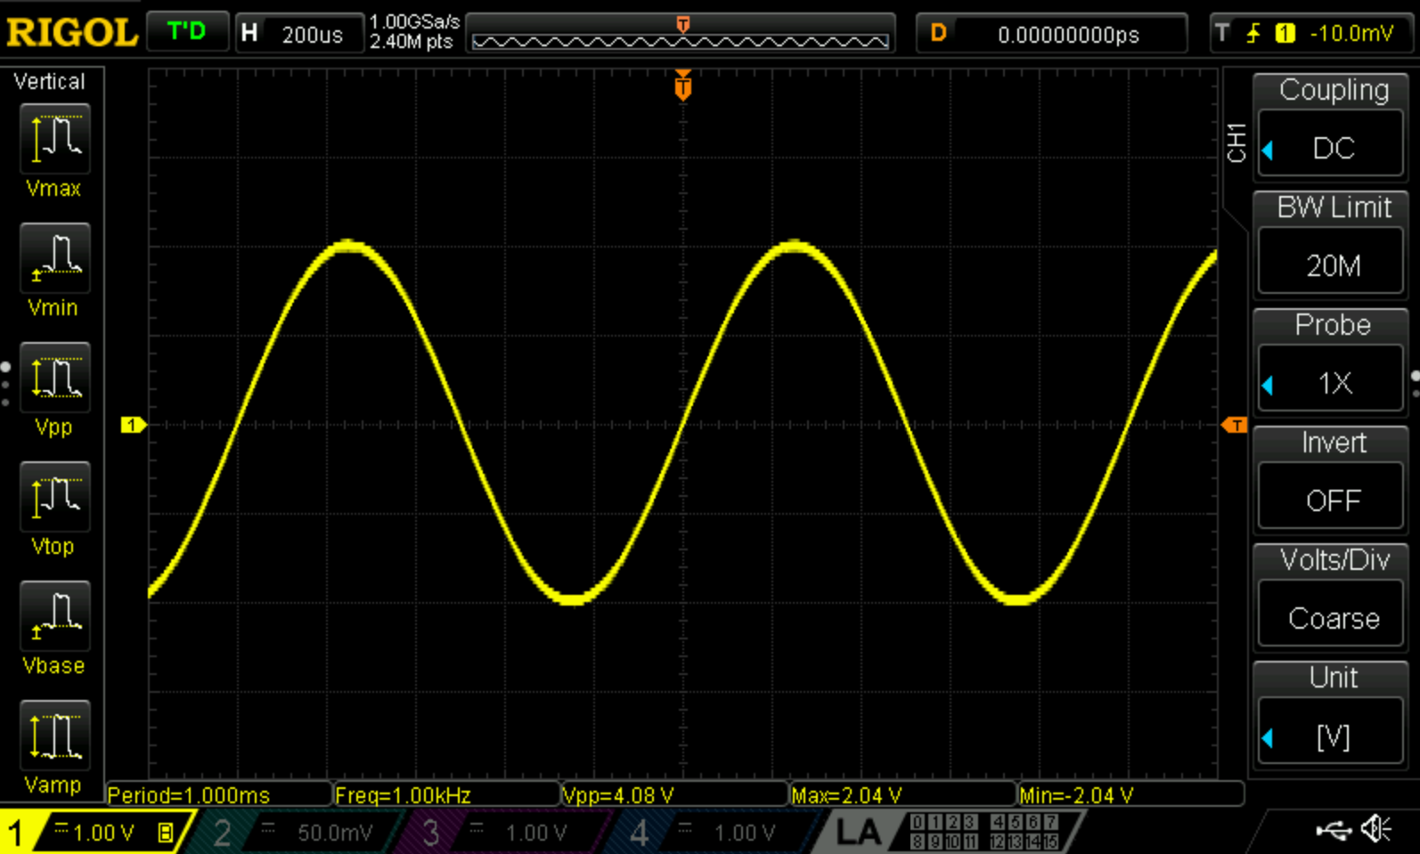

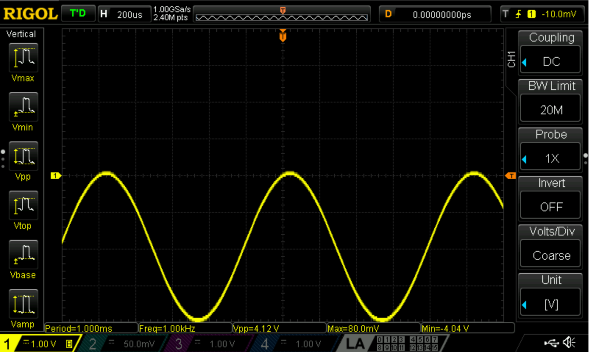

**Part 2-8: explore the scope’s triggering operation**

1. Triggering is the mechanism that controls the moment when two subsequent portions of a repeating AC signal are redrawn on the scope’s screen. If a subsequent signal portion is not drawn as soon as a preceding signal portion ends, then the overall waveform will NOT appear stationary. You will see a waveform that is dancing. This dancing wave display is hard to analyze, and should be avoided. The following is an image of a dancing wave.

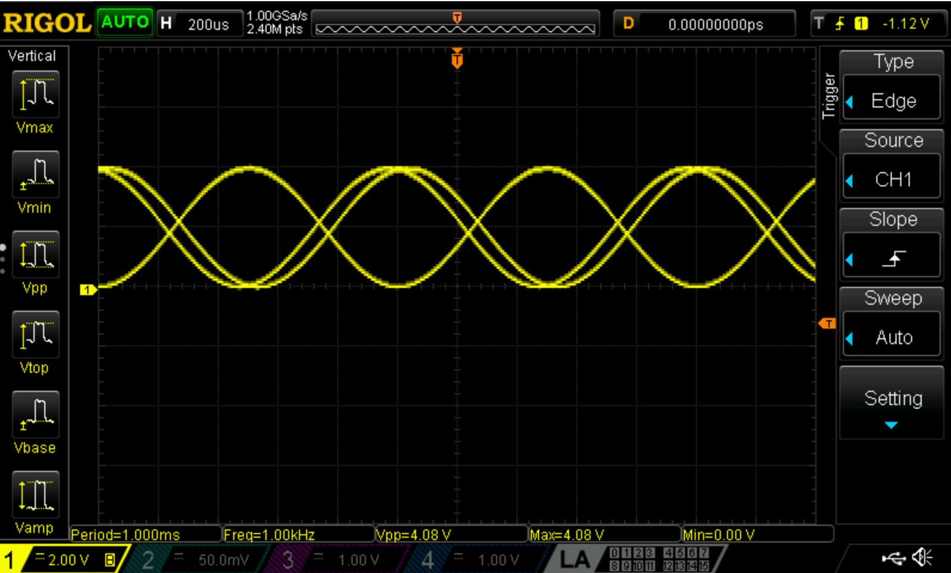

1. Often when looking at signals with a scope, you're almost always looking at a repeating signal. Triggering allows you to horizontally align the repeating parts of this signal. When the scope sees a trigger event, it knows to put a trace onto the screen horizontally aligned with the *Trigger Alignment Indicator* (see orange pointer with a little “T” in it in the image). A trigger event happens when the *Trigger Level* is inside the waveform’s voltage (i.e., the waveform’s vertical) range. This allows a repeating wave to be overlaid on top of itself in such a way that it reinforces previous trace to make the trace appear stationary. It is much easier to analyze a stationary wave than a running wave, which is why we need to perform the triggering operation if needed.
2. Dial the trigger control knob at the right side of your scope. You should see an orange trigger level moving up or down the screen. Adjust the trigger level to a level that your sine-wave signal never reaches. You should see the wave dancing across the screen. Now, move the trigger level back to meet your signal. You will see that your wave is now stabilized. The following is an image of a stable wave after triggering is properly performed.

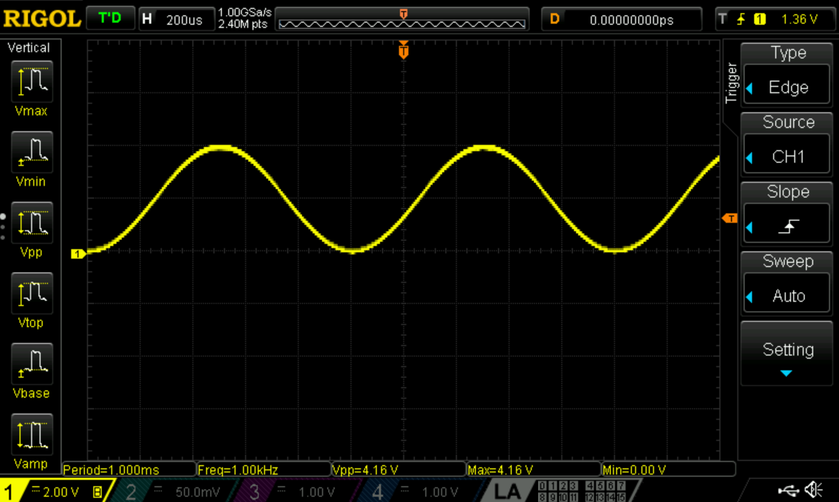

**Save an image with misaligned trigger (dancing wave), and another image with aligned trigger (stationary wave).**

**Part 2-9: applying a math function to process two signals**

1. Connect the scope’s Ch-1 and Ch-2 to the function generator’s Ch-1 and Ch-2, respectively. This can be easily done with BNC cables. Make sure the scope’s Probe setting for both Ch-1 and Ch-2 are set to 1X (factory default setting is 10X).
2. Output both Ch-1 and Ch-2 signals from the function generator to the scope. Ch-1 signal is 1kHz, 4Vpp, 2Vdc offset; Ch-2 signal is 2kHz, 5Vpp, 0Vdc offset.
3. Press **Auto**. If needed, use the trigger knob to stabilize both waveforms. You should now see both waves on the scope. Use the vertical scale knob to adjust the Ch-1 and Ch-2 waveforms so that both waves have the same vertical scale. We will now add the two waves using the scope’s Math function.

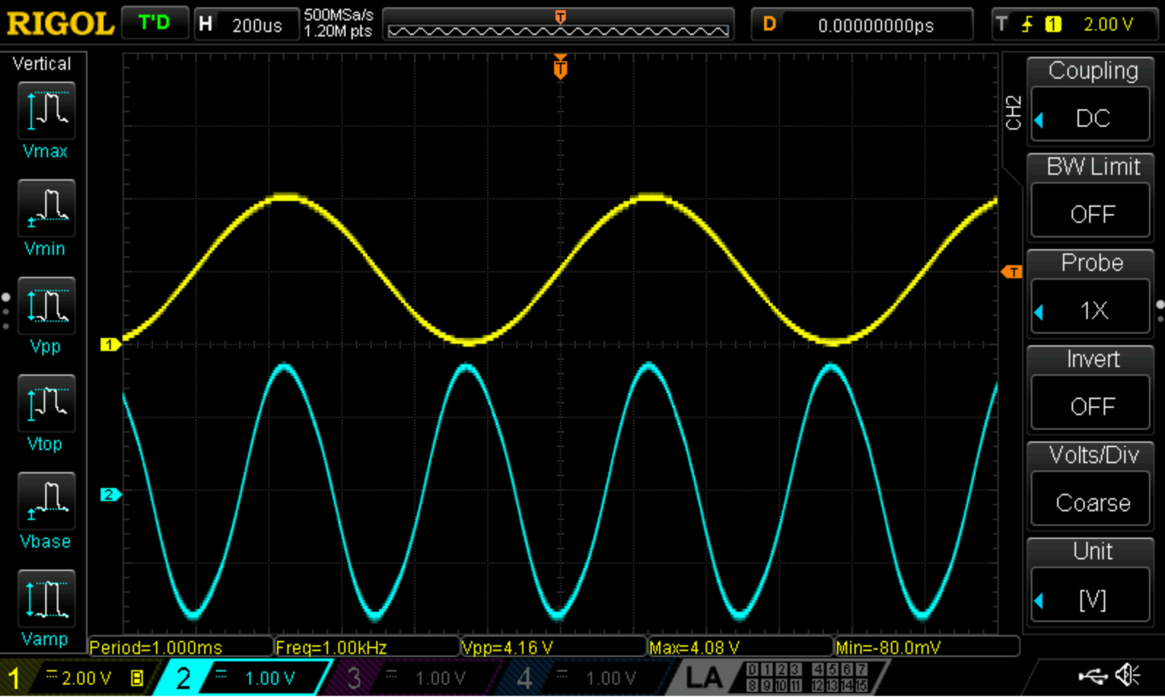

1. Press the Math button. Select one of the math functions to be A+B. Set the Operation to “ON”. You will now see a third wave representing the sum of the two waves. Push the “MATH” knob to select this wave, and use the vertical scale knob to shrink this signal within the screen. **Save your image that displays all the three waves (Ch-1, Ch-1, and A+B).**

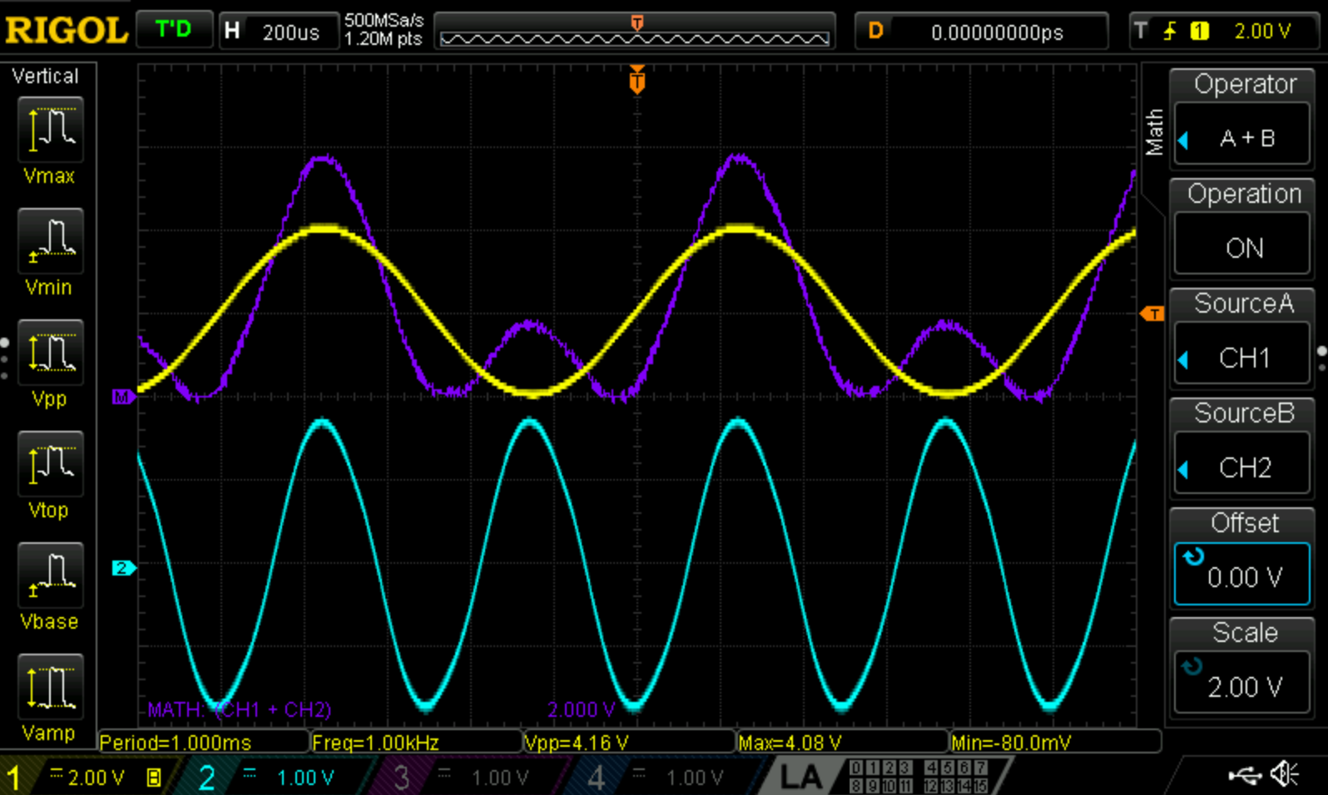

1. Increase the amplitude (Vpp) of the lower frequency Ch-1 signal from 4Vpp to 8Vpp. Then increase the frequency of the higher frequency Ch-2 signal from 2kHz to 8kHz. **Record what you see on the scope.**

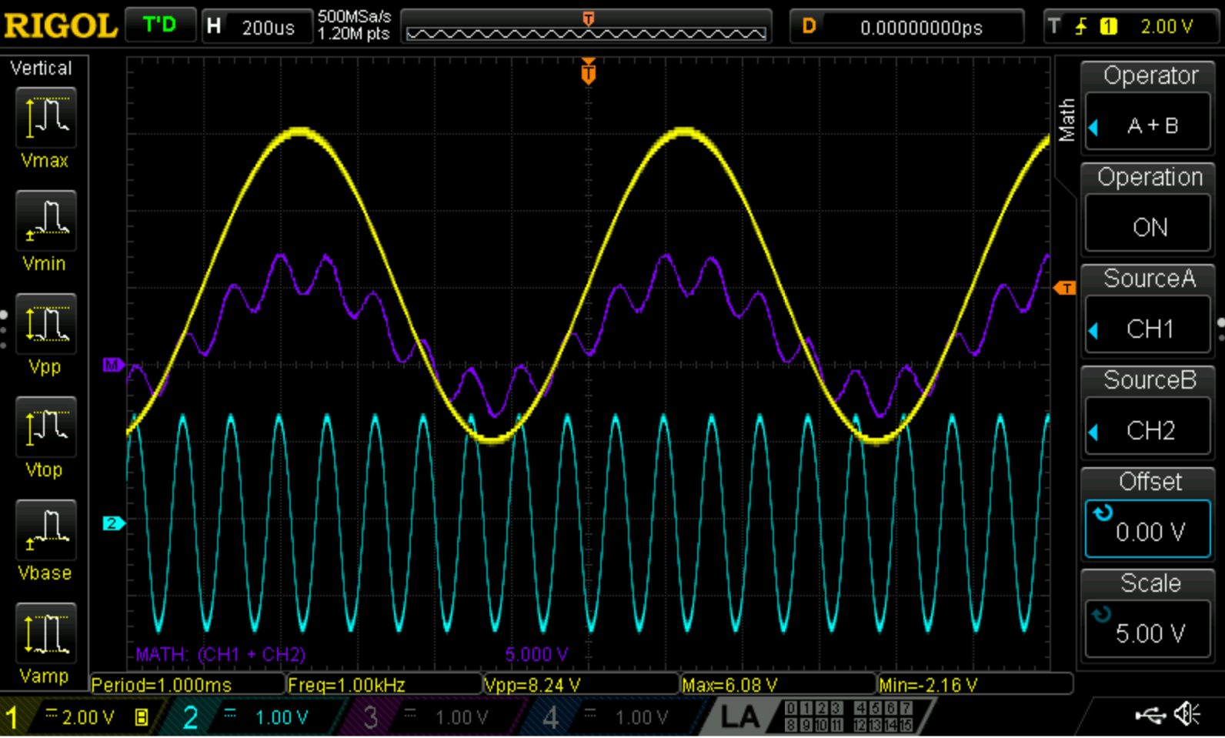

**List of items to include in your lab report results section:**

Part 2: include waveform that you saved on your thumb drive

d) one image of square wave for probe calibration

h) one image of regular sine wave

o) two images showing offset with scope’s DC coupling

p) one image of an offset signal with scope’s AC coupling (showing no offset)

s) one image of a dancing wave without triggering

u) one image of a stationary wave with proper triggering

y) one image of three waves under a MATH operation

z) one image of another three waves under a MATH operation